**Logo-** 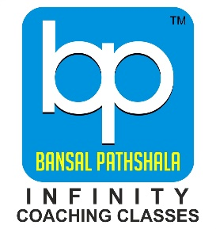

**Name - BANSAL PATHSHALA**

**Address-  2nd floor morey sadan, opp. Bajaj KTM showroom, Nagpur, Maharashtra 440001**

**Phone No-**[**084211 11696**](https://www.google.com/search?q=BANSAL+PATHSHALA&stick=H4sIAAAAAAAA_-NgU1I1qDBOSjFJNjRNtjA1tTROMzC0MqhITUozTDFNTLIwNkixME4yW8Qq4OToF-zooxDgGOIR7OHo4wgAp0IsJjwAAAA&hl=en&mat=CW0ZSho4d1AAElcBqiIDwgYkOVoikTOfHlLpFTJtZ4tfBP1dngXrXGAaB8ha1hiLun70hZmek-AjOkDhHTVH-kXtasKR2EcDZRGrHnTu6l69nlOSClJucYucMa5-Kip9HPs&authuser=0) **Bansal Pathshala - The Best Coaching Centre in Nagpur for IIT, JEE, NEET, and CBSE**

**Looking for top-notch coaching in Nagpur? Bansal Pathshala is your ultimate destination for academic excellence. As a leader in IIT coaching in Nagpur, we provide comprehensive training with experienced faculty, ensuring success in competitive exams. Whether you're searching for IIT coaching classes in Nagpur or the best JEE coaching in Nagpur, we’ve got you covered with result-oriented methods and personalized guidance.**

**Our NEET classes in Nagpur are designed to help aspiring doctors excel, while our CBSE coaching classes in Nagpur ensure strong foundational learning. Join us for success in every academic endeavour. Visit Bansal Pathshala today!  
  
  
IIT in Nagpur, IIT classes in Nagpur, IIT coaching in Nagpur, IIT coaching classes in Nagpur, Jee classes in Nagpur, Jee classes Nagpur, Best Jee coaching in Nagpur, Jee coaching classes in Nagpur ,Jee coaching in Nagpur, Best coaching for Jee in Nagpur, Best institute for Jee in Nagpur, Jee Neet classes in Nagpur, NEET classes in Nagpur, Best NEET classes in Nagpur, Best coaching for Neet in Nagpur, Best NEET coaching in Nagpur, NEET coaching in Nagpur, Neet coaching classes in Nagpur, CBSE coaching classes in Nagpur.**